Easy MySQL Setup

Open MySQL workbench, connect, and then right click on the left and click “create schema” as shown below:

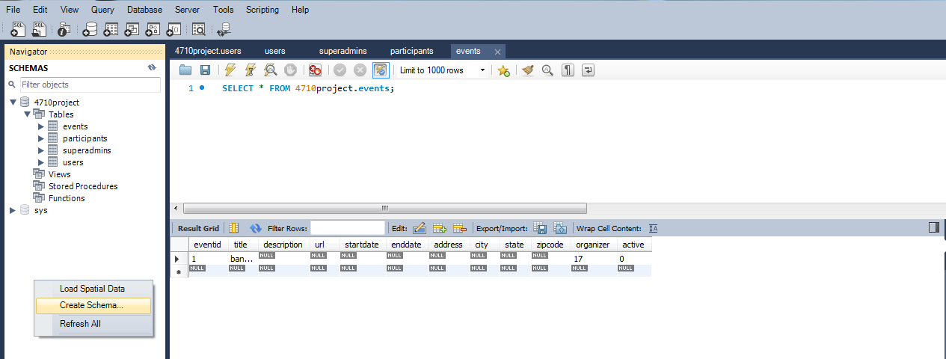

type in: 4710project and click apply:

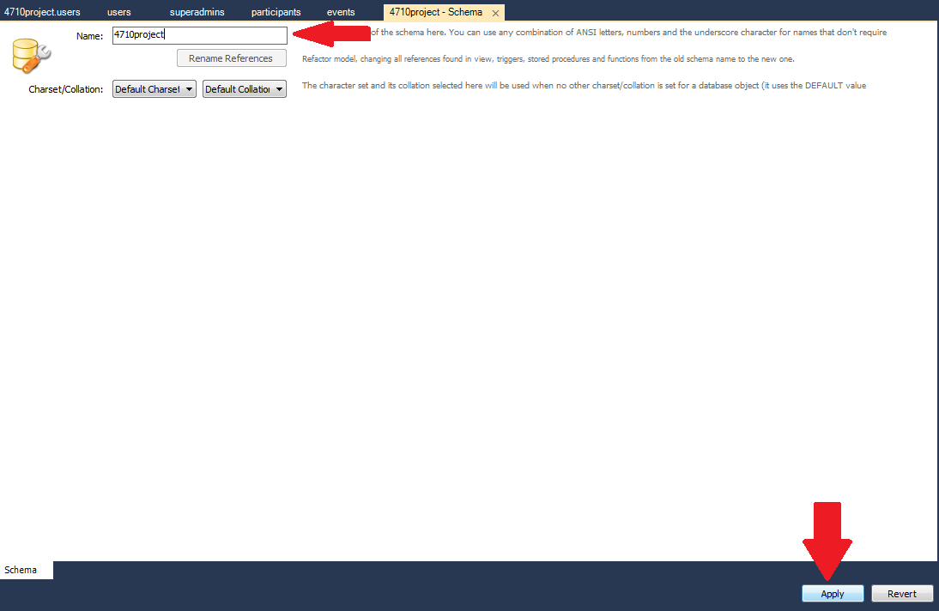

This screen should come up. Copy and paste from database.sql, then click apply. This should auto generate all the tables and create the schema for you.

